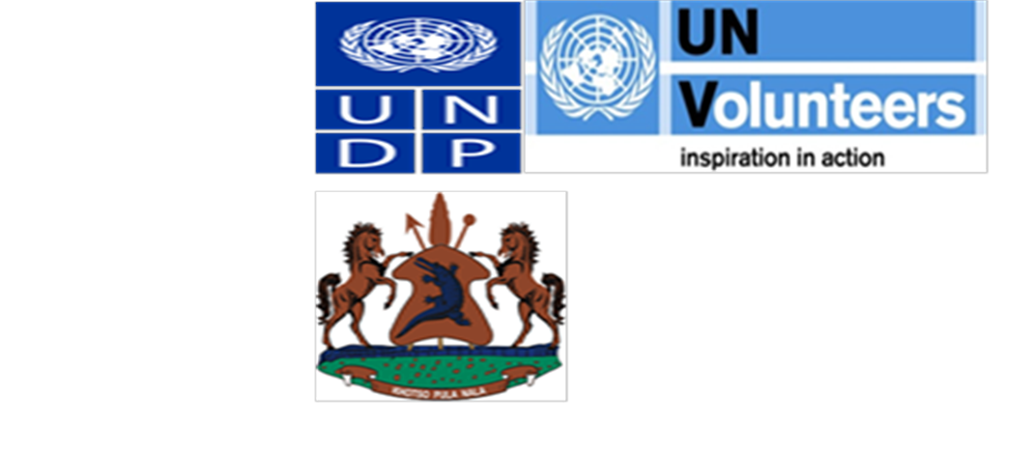
FINAL EVALUATION REPORT
FOR THE
PROGRESS AND ACHIEVEMENTS OF THE NATIONAL VOLUNTEER CORPS AND THE UNITED NATIONS VOLUNTEER MEDICAL DOCTORS PROJECTS IN LESOTHO 2014
BY

CLIFF BERNARD NUWAKORA
C/o CASE International Consultants Ltd
Tel. +256 772 525 661, KAMPALA UGANDA
Email: cliff.nuwakora@gmail.com, cliff@caseconsultug.com
Website: www.caseconsultug.com

2015

Table of Contents
List of Acronyms and abbreviations iii
Executive Summary iv
1. INTRODUCTION 1
1.1 Background and Objectives of the Projects 1
1.2 The context of the projects’ interventions 3
1.3 The scale of the evaluation 4
1.4 Purpose and Objectives of the Evaluation 5
1.5 Scope of the Evaluation 6
2. METHODOLOGY 7
2.1 Methods of Data Collection: 7
2.2 Data Management and Analysis 7
2.3 Limitations to the review 7
3. FINDINGS 9
3.1 Part A-National Volunteer Corps (NVC) 9
3.1.1 Introduction 9
3.1.2 Achievements 9
3.1.3 Challenges 11
3.1.4 Projects’ Relevance to the national development frameworks 12
3.1.5 Projects’ Effectiveness 12
3.1.6 Assessment of design and implementation of the Projects 15
3.1.7 Linkages between the project and other interventions within the sector 16
3.1.8 Management arrangement of the project 17
3.1.9 Rating of project implementation (employing six-point UNDP Rating Scale) 20
3.1.10 Rating of Progress towards project objectives and outcomes (employing the six-point UNDP rating scale 21
3.1.11 Lessons learned 22
3.2 PART B: UNITED NATIONS VOLUNTEER MEDICAL DOCTORS 23
3.2.1 Introduction 23
3.2.2 Achievements 23
3.2.3 Projects’ Relevance to the national development frameworks 24
3.2.4 Projects’ Effectiveness 25
3.2.5 Project’s Efficiency 27
3.2.6 Assessment of design and implementation of the Project 28
3.2.7 Rating of project implementation (employing six-point UNDP Rating Scale) 30
3.2.8 Rating of Progress towards project objectives and outcomes (employing the six-point UNDP rating scale 31
3.2.9 Lessons learned 32
4. CONCLUSIONS AND RECOMMENDATIONS 33
4.1 Part A: National Youth Corps 33
4.1.1 Conclusions 33
4.1.2 Recommendations 33
4.2 Part B: UNV Medical Doctors Volunteers 35
4.2.1 Conclusions 35
4.2.2 Recommendations 36

List of Acronyms and abbreviations

ART Anti-Retroviral Therapy
ARV Anti-Retroviral
CBO Community Based Organization
CPAP Country Programme Assistance Plan
CSOs Civil Society Organisations
DED Deutsche Entwicklungs Dienst (German Volunteer sending Organization)
HIV/AIDS Human Immunodeficiency Virus/Acquired Immunodeficiency
HIV/TB Human Immune Virus /Tuberculosis
ILO International Labour Organization
INGO International Non-Governmental Organisation
LUNDAP Lesotho United Nations Development Action Plan
M&E Monitoring and Evaluation
MDGs Millennium Development Goals
MGYSR Ministry of Gender and Youth, Sports and Recreation
MoHSW Ministry of Health and Social Welfare
NGO Non-Governmental Organization
NSDP National Strategic Development Plan
NVC National Volunteer Corps
NVI National Volunteer Infrastructure
PLWHA People Living with HIV/AIDS
PRS Poverty Reduction Strategy
PRSP Poverty Reduction Strategic Plan
RC Resident Coordinator
UN United Nations
UNDAF United Nations Assistance Framework
UNDP United Nations Development Programme
UNDP/UNV United Nations Development Programme/United Nations Volunteers
UNFPA United Nations Population Fund
UNICEF United Nations Children’s Fund
UNV United Nations Volunteers
USAID United States Aid for International Development
V4D Volunteerism for Development
VIO Volunteer Involving Organisation
VSO Volunteer Service Organization
YEP Youth Empowerment Project

Executive Summary
A brief description of the Projects’ purpose
The purpose of the two projects (National Volunteer Corps and the United Nations Medical Volunteers) was to promote the volunteerism spirit for development, help in fight against HIV/AIDS prevalence and contribute to realizing national and international development agenda in the Republic of Lesotho.
Specifically, the purpose of the National Volunteer Corps (NVC) project was to provide a mechanism for the youth (University and third level technical training institutions) gain work experience through access to volunteer opportunities in public, private sector, NGOs, bilateral and multilateral organizations.
The key partners in the running the project were the Ministry of Gender and Youth, Sports and Recreation (MGYSR) supported by the United Nations Volunteer Programme and the United Nations Development Programme (UNDP). The project initially planned to run for three years 2010-2013 was extended to 2014 with an intention of providing adequate time for it to metamorphose into a national programme under government stewardship and funding.
While the United Nations Volunteer(UNV) Medical Doctors Project purpose was to address the human resources gaps in the health sector through recruitment of Volunteer Medical doctors and deploying them so that they provide health care services at different levels of the health care system within Lesotho. The support of UNV Medical doctors was supposed to make a significant contribution in Lesotho's efforts to address the human resource crisis in the health sector as well as a direct contribution towards the attainment of Millennium Development Goals. The was developed in 2009 as collaboration between the Government of Lesotho, WHO, UNDP and UNV under the short-term Emergency Human Resource Plan to address the human resources gaps in the health sector.
Findings
The findings are presented in two parts with each part covering a project. Part A covers the National Volunteers Corps Project and Part B is about United Nations Volunteers Medical Doctors.
PART A-NATIONAL VOLUNTEER CORPS (NVC)
Achievements
- There was a well-established database of over 7,000 volunteers created which provides a pool to which various agencies can tap from. The target was to place 150 youth was exceeded. In 2013 alone 513 volunteers had been placed a number way over and above the targeted 300 volunteers. Around 60% of the beneficiaries have gained permanent employment.
- The prospects of the project transforming into a fully-fledged programme have been fully realized. By the time this evaluation was carried out, the government had fully funded programme operationalized under the Ministry of Gender, Youth Sports and Recreation (MoGYR). Requisite staff has been recruited and partnerships with projects YEP-Youth Empowerment, WEDGE and social compact are likely to reinforce sustainability of the project outcomes.
- Furthermore, the NVC project staffs also were able to contribute in the review and development of National youth policy as key milestone in the direction towards concretizing on realizing project outputs.
- However, the achievements notwithstanding, notable challenges influenced the smooth implementation of the project that are worth mentioning include: the delays to recruit appropriate technical staff(Project Coordinator, Accounts Assistant or HR Officer.) to run the project contributed to sluggish implementation of activities.
- Within some host institutions for NVCs, there were no clear cut roles and responsibilities defined for the volunteers hence this led to redundancy and in other cases allocated responsibilities that did not match their training needs like manual tasks of carrying loads. In other cases there was lack of basic facilitation such as office space, desks, chairs, stationery, computers; and poor and lack of effective transport and accommodation.
- Unforeseen drastic changes to the Procurement and Accounting systems within the Government Ministries caused severe delays and cancellations to project activities. The evaluation noted that due to this development the efficiency and effectiveness were in a way compromised.
- The management teams were also constrained by limited time and periods to carry out field supervision and monitoring visits hence couldn’t cover all locations where volunteers for both projects were placed.
- There was a lose coordination in decision making between the host Ministry and the NVC Project in that critical decisions were often and the lose coordination often interfered with smooth operations especially the delayed budgets.
RECOMMENDATIONS
The evaluation strongly recommends for following:
- Since the project has changed from project to programme there is need to enhance its implementation through the decentralized structure up to the district level to ensure there is wide coverage that exhibits national outlook and inclusive of all segments of the youth population.
- Ministry of Gender, Youth and Social Recreation that is responsible for the programme should come with laws and policies that ensure the Private sector, CSOs and Development partners make volunteers roster as a mandatory resource pool from which Human resources should be recruited so as to motivate the youth.
- As for the future if the programme is to be strengthened, there will also be a need for an M&E system for the whole programme in order to check/monitor if other activities/objectives are achieved/been held so as to track efficiency and effectiveness of the programme.
- There should be concerted efforts on the part of government and other stakeholders to mobilize youth who gain permanent jobs placement thereafter to contribute to the funding of NVC as part of the strategies to grow and strengthen it as self- financing entity.
- All the programmes to be implemented under the development assistance frameworks like UNDAF and CPAP and national development agenda should build on foundation laid down by the project and ensure volunteerism targeting the youth forms a core component. This opportunity should be exploited in the post MDG agenda.
- The Lesotho Government should fast track the policy and legal framework on to which the programme should be anchored so as to ensure that institutional framework with requisite skilled personnel and funding are put in place to have the project run smoothly to avert the risk of failure in future.
- UNDP country office should continue to support the project now turned into programme so as to ensure it’s much more robust as a fully self-sustaining government programme. This kind of support may be in form of financial and Human resources (post assignment/graduate training courses, career guidance sessions)
- There is need in future for the UNV office and governments to mount frequent checks and monitoring of host institutions in order to follow up on the working environment and performance of volunteers.
- Finally, there is need for the inclusion young people in the management of the programme by the MoGYSR as a way of ensuring its sustainability. Note that young managers are likely to appreciate the aspirations of fellow young people.
PART B: UNITED NATIONS VOLUNTEER MEDICAL DOCTORS
Achievements
- Despite delays in recruitment of volunteer doctors and their placement in district hospitals, notable achievements note worth were realized. They include:
- The training and capacity building though not well structured, UNV Medical doctors based in Maseru carried out trainings in the outlying districts that was aimed at building the capacity of the local staff. This was also augmented by the UNV Medical doctors’ resident in the districts that on some occasions carried out outreach visits to surrounding communities hence contributing to increased access improved health services.
Challenges
- Delayed recruitment process led to loss of already identified quality specialists to other countries (Malawi) and organizations. This was also due to slow response from the Ministry of Health and Social Welfare (MoHSW) at assessing applications of the UNV Medical Doctors presented to them by UNV. This lukewarm response from the Ministry showed affected the timely delivery of the critical input –the Medical doctors, sign of limited ownership of the process from the right from the start.
- Language barrier was also reported to have affected the project implementation since in some cases the UNV Medical doctors were misinterpreting the patient information which bred some confusion as well as infringement on the patient rights. This same factor also in some cases led to long hours a doctor could spend on attending to a patient.
- Some of the doctors were challenged due to the fact that they were coming from HIV relatively free countries hence had no practical skills in managing HIV/AIDS cases. Belatedly, they also had difficulties and challenges in administering some new drug regimens quite different from their countries of origin which they had never administered before or had been phased out in their home countries.
- The fact that there was no full induction program the doctors lacked some pre-arrival information package that could not readily enable them perform their duties smoothly. Since all UNV doctors were foreigners this posed a challenge in being fully integrated within the local hospital systems and structures which affected the coordination of the day to day assignments.

Recommendations
- Recommendations are intended to guide streamlining the current implementation, bridge the weaknesses as well as building on the existing strengths of the project to ensure sustainability of the outcomes.
- In future the UNV doctors should be deployed in the districts as opposed to being placed at the MoHSW headquarters since there is more need in the districts due to lack of skilled medical staff.
- There should be deliberate efforts by the Ministry of Health and Social Welfare to use the project as a key capacity building initiative of local junior medical staff by drawing up plans and targets in respect to skills and knowledge needed so as to adequately address the human resource gaps in the health sector.
- The monitoring system should be revisited by the MoHSW to make it much more responsive to capturing the detailed data right from the service delivery point to the ministry level so that accurate statistics are captured to inform future planning in the health sector to address the human resource gaps.
- Specifically for the UNV Office, there is need for recruitment of a Technical Program Assistant to support the current UNV Program Manager since the substantive UNV Program Assistant was handling Administrative/financial management support than technical UNV work.
- To ensure continuity of the benefits, there is need for more UNV doctors and this time recruitment should be scaled up so that in the successor program, the highly needed medical personnel specialized in clinical disciplines such as Gynecology, Obstetrics, Orthopaedic surgery, Anesthetic, Paediatrics are recruited as opposed to general practitioners and public health specialists.
- UNV doctors recruitment should target doctors from the region as a priority and if they cannot be found, then doctors recruited outside the region should be fully inducted and taken through courses in the basic local language training to enable them have a better start in the hospitals where they are placed
- There is need to decentralize Doctors not only to government hospitals but also placing some under the Public Private Partnership arrangement in private hospitals that serve a bigger catchment area as well as fully equipping and staffing them to the level of a provincial referral hospital.

- Apart from Specialist UNV Medical Doctors, the government should also provide psycho social counselling services to the patients especially with this HIV/AIDS epidemic where UNV medical doctors were challenged. This would enable doctors’ focus more on their core functions of rendering specialized services as and when required.
- There is need for the government to provide adequate equipment and facilities(basics for Anesthesia and oxygen) in order for the specialists to effectively deliver their services at the place of work.
- In future MoHSW/UNV should develop an orientation program for the new volunteers recruited both at national and district levels. The doctors’ orientation should introduce them to full information on health service delivery system within the country as well as policy and regulatory framework, HIV/AIDS, drug regimes, social and cultural norms and values of the country.
- Lesotho being a hard hit country by HIV/AIDS, there should be concerted government effort together with development partners in continuing special focus on practical strategic initiatives in addressing the HIV/AIDS scourge since it has a direct correlation with the level of poverty and unemployment especially with the youth.

INTRODUCTION

This final evaluation is an undertaking by Cliff Bernard Nuwakora (M&E Consultant) on behalf of UNDP/UNV in partnership with Government of Lesotho to assess the progress and achievements of THE NATIONAL VOLUNTEER CORPS AND THE UNITED NATIONS VOLUNTEER MEDICAL DOCTORS PROJECTS IN LESOTHO 2014. The evaluation was undertaken in November 2014 and the consultant in the course of the evaluation interfaced with a number stakeholders including UNDP/UNV, Government’s Ministries of Health and Social Welfare and Gender, Youth and Recreation respectively, district government Officials, UN Volunteers, Project Staff to gain insights into project performance during the period under review.
This report is structured along the following broad headings: - Background and objectives, findings, and conclusions and recommendations; and Annexes.

Background and Objectives of the Projects
- National Volunteer Corps
The National Volunteer Corps project primary purpose was to provide a mechanism for the youth (University and third level technical training institutions) gain work experience through access to volunteer opportunities in public, private sector, NGOs, bilateral and multilateral organizations. The key partners in the running the project were the Ministry of Gender and Youth, Sports and Recreation (MGYSR) supported by the United Nations Volunteer Programme and the United Nations Development Programme (UNDP).The targeted beneficiaries of the project were young unemployed graduates (below 35 years of age) interested in volunteer work through rendering services in their area of training or expertise at various levels including community development work. The project initially planned to run for three years 2010-2013 was extended to 2014 with an intention of providing adequate time to mature into a national programme under government stewardship and funding. With funding from the Special Volunteer Fund of UNV (US$ 223,200), UNDP – Lesotho (US$ 161,900) and the Government of Lesotho (US$ 413,344), the project commenced in earnest in October 2009.
The objectives of the project as stated from the outset were:
  - To support the Lesotho Government to set up a National Volunteer Corps Programme for young graduates.
  - To mobilize young professionals to support Lesotho’s development efforts through volunteer work.
  - To complement ongoing efforts by government, UNDP and other national institutions that are working towards implementing various development programmes including the MDGs and PRSP in the country.
  - To promote coordination among volunteer involving organizations in the management of volunteers and their contribution to defined development priorities.

B. The UNV Medical Doctors Project
The United Nations Volunteers (UNV) Medical Doctors Project was started in 2009 as collaboration between the Government of Lesotho, World Health Organization (WHO), United Nations Development Program (UNDP) and United Nations Volunteers (UNV) under the short-term Emergency Human Resource Plan to address the human resources gaps in the health sector. The project recruitment volunteer Medical doctors and deployed them to provide health care services at different levels of the health care system within Lesotho. The programme was supposed to augment the WHO medical staff comprehensive training programme that was already under implementation in the health sector. Thus one of the objectives of the project initiative was to serve as a stop gap measure to allow for time when qualified medial staff would be available under WHO programme short term Emergency Human Resource Plan. As one of its key inputs, the project recruited and deployed qualified medical doctors who were tasked to contribute to improved health service delivery as well help in building the capacity of in-service local medical professionals.
The support of UNV Medical doctors was anticipated to make a significant contribution in Lesotho's efforts to address the human resource crisis in the health sector as well as a direct contribution towards the attainment of Millennium Development Goals as illustrated hereunder:
  - MDG 4 Reduce child mortality: To reduce by two thirds the mortality rate among children under five by 2015.
  - MDG 5 Improve maternal health: To reduce by three quarters the maternal mortality ratio by 2015
  - MDG 6 Combat HIV/AIDS, malaria and other diseases: To halt and begin to reverse the spread of HIV/AIDS
The joint programme also was supposed to have an indirect contribution towards MDG 1 Eradicate extreme poverty and hunger.
Furthermore, beyond focus on improving delivery of health services to all, it was also aligned in such way as to contribute to the multiple outcomes in the Lesotho United Nations Development Assistance Framework (LUNDAF) 2013 – 2017 as hereunder listed:-
  - Outcome 7: Equitable access o and utilization of high-impact, cost-effective health and nutrition interventions achieved for vulnerable populations
  - Outcome 8: Vulnerable groups have access to adequate and effectively managed (HIV/AIDS, Child and Gender-sensitive) social protection system)
  - Outcome 9: Multi-stakeholders in the country contribute to the reduction of new annual HIV infections especially among youth, children and adults
  - Outcome 10: Persons living with HIV have access to and benefit from the integrated service delivery that includes nutrition support, ART and care; ad HIV/TB co-infection management.
  - Outcome 3: National and local Governance structures deliver quality and accessible services to all citizens respecting the protection of human rights and access to justice, and peaceful resolution of conflict.
None the less, the project complemented other efforts from development partners such as the Millennium Challenge Cooperation, Irish Aid and other projects that supported the improvement of the infrastructure and equipment in health facilities across the country. It has further sped up retooling the government regional hospitals in the South, North and Central regions with intent of improving the quality of health care provided to the people of Lesotho.

The context of the projects’ interventions
Lesotho is land locked covering an area of 30,355km with only one neighbour- the Republic of South Africa. The population of Lesotho is estimated at 1.8 million and majority (76.2%) majority reside in rural areas. Given the mountainous of Lesotho more than 80% of the country is located 1,800m above sea level, thus difficult topography poses serious challenges in transport.
Lesotho faces enormous challenges that include: high prevalence of HIV/AIDS combined with deep-rooted poverty and food insecurity that render almost every household vulnerable to severe shocks.
No wonder, half of the population now lives below the poverty line. This level of poverty has become chronic and is attributed to reduced household incomes and reduced employment opportunities for the large number of returning migrant miners. Chronic poverty and food insecurity are responsible for vulnerability to HIV/AIDS and the most affected are women some of who engage in risky sexual behavior to earn a living which exposes them to infections. Women are disproportionately affected by poverty, HIV and AIDS, which makes a gender sensitive CPAP imperative.
The level of unemployment is estimated between 23 and 35 percent and tends to be higher among the youth (40 percent). Quite disturbing is that the vocational and training systems have not enabled youth easily successfully access both the formal and informal labour markets. Of the estimated 25,000 young girls and boys who enter the labour market each year, half of them do not find a job.
Given the above scenario, UN system and agencies have been working hand in hand with Lesotho government to support initiatives aimed at improving the wellbeing of all Basotho. This has been done as prescribed in the UN charter by supporting priorities in the Lesotho’s National Strategic development plan and Vision 2020.
As matter of fact, efforts have been made by the UN system agencies to align the development assistance programme in conformity with Lesotho United Nations Development Assistance Plan (LUNDAP); a five year National Strategic Development Plan for the period 2012/13-2016/17.Each of the outcomes envisaged from the LUNDAP is derived from the strategic objectives of the National Strategic Development Plan (NSDP).
One of the key pre-occupations of the UN system in Lesotho has been the promotion of skills development. This has been done through a number of initiatives that include a developed pool of international, regional, and in-country expertise; facilitating dialogue among political groups; enhancing advocacy for marginalized groups of the population; responding swiftly to the emergency humanitarian needs, facilitated development of policies, plans and frameworks; and increased knowledge base for informed policy making. The UN System used this comparative advantage to inform the development of the LUNDAP.
Thus, in order to support the government of Lesotho address some of the social economic challenges of Youth unemployment, poverty in general and HIV/AIDS scourge, the UN system came up with the two projects namely: UNV Medical doctors and National Volunteer Corps to kick start initiatives aimed towards contributing addressing Lesotho national development challenges highlighted above.
At the inception of the projects, it was hoped that through spirit of volunteerism some of the challenges will be addressed. Therefore, the object of this evaluation is to assess the achievements these two volunteer schemes in meeting their objectives as envisioned in the project design documents.

The scale of the evaluation
This evaluation covers two projects namely:- the National Youth Corps and the UNV Medical Volunteers. The purpose of the evaluation was to assess the extent to which each of projects achieved its objectives. The key indicators of achievements were measured against the anticipated intended outcomes, emerging indicators of their sustainability and how they have contributed to the overall goal of national development (NSDP) and international commitments (MDGs).
Specifically, during the evaluation of the United Nations Volunteer Medical Doctors attempts were made to assess the extent to which UNV Medical volunteers helped address the specialized human resource gaps in the health system and how it contributed to the efficient and effectively service delivery in the health sector. In order to realize the objectives of the evaluation, the consultant sought views of the implementing partners, beneficiaries and other relevant government agencies with a view to gain insights on emerging issues on results, sustainability, risks and possible avenues of how the project can be supported in future..
The National Youth Volunteer Corps evaluation equally focused on the extent to which project objectives were realized and how that has contributed to increased number of youth graduates in (tertiary and University) seeking volunteer opportunities in order to gain experience, skills and network opportunities that would enable them access employment in different sectors. Overall assessment was therefore to gauge whether this project was actually helping overcome unemployment among the graduate youth. In order to realize the objectives of the evaluation, the consultant sought views of the implementing partners, beneficiaries and other relevant government agencies with a view to gain insights on emerging issues on results, sustainability, risks and possible avenues of future support.
The Projects’ Resource Envelope
This sub-section of the report brings out mobilized resource envelop for each of the projects. The resources looked at in this evaluation include human and financial resources and what each of the partners contributed.
To ensure the projects take off, human and financial resources were mobilized as critical inputs towards realization of projects. For each of the projects, the resources marshalled as shown below:
The United Nations Volunteers Medical project total estimated budget for four year project duration was US$ 4,784,210.The sources of the funds were contributed by Unite Nations agencies-UNV and UNDP. The UNDP office served as the managing agent and provided critical technical support to ensure the project activities were implemented as prescribed in the project document. The Government of Lesotho represented by the Ministry of Health and Social Welfare (MoHSW) and Ministry of Finance and Development Planning (MoFDP) provided human resources and office space that supported the project implementation.
Concerning the resource mobilization for the NVC project, a total of US$ 882,444 was budgeted for the three year project duration. Of the total budget UNV was to contribute US$ 223,200, bilateral donors US$ 84,000 and the government of Lesotho US$ 413,344.the implementing partner on behalf of government was the ministry of gender, youth sports and recreation and other partners were UNV, donors, NUL, NAC, and NGOS,
The Key stakeholders in projects implementation
National Volunteers Corps
The project was initiated principally to help government of Lesotho achieve the MDGS and reduce poverty through helping youth access volunteer opportunities that will help them gain skills and experience that will enable them gain employment opportunities. The principle implementing partners were the Ministry of Gender and Youth, Sports and Recreation (MoGYSR), UNV and donors. Other partners include NUL, NAC, and Non-Government Organizations (NGOs). The role of the Ministry of Gender, Youth Sports and Social Recreation (MoGYSR) was to provide office accommodation as well as coordinate the project, while the United Nations Volunteer Office provided technical support. NGOs and Private Sector provided opportunities for the volunteer placement. In the course of the project implementation, the evaluation noted that all the partners have lived up to their roles and expectations and the success the project could be attributed largely to harmonized operations and complementarity of the partners during the execution of the project.
UNV Medical Doctors
This programme was collaboration between the Government of Republic of Lesotho and the UN agencies (WHO, UNDP and UNV). The role of the Government of Republic of Lesotho through the Ministry of Health and Social Welfare(MoHSW) to identify areas of need in the Health Sector to enable the UNV identify the right medical professionals required. UNDP performed the role of coordinating and funding agency while WHO provided technical support. The ultimate objective was to support Government of Republic of Lesotho deploy medical doctors for provision of health services at different levels of the health care system so as to improve health services delivery in the country as well as address the human resource gaps.

Purpose and Objectives of the Evaluation
According to the specific ToR the purpose of the evaluation was to achieve the following:-
1. To help the funding agencies and UNDP/UNV to assess the achievement of the interventions and projects’ objectives, and intended outcomes and impacts, remaining gaps in policy and action in the Projects as well as offer stakeholders an opportunity to capture the lessons learnt from this experience.
2. To provide a valuable opportunity to assess signs of ultimate projects’ success and lessons learnt and prompt necessary adjustments in projects’ design and management. UNDP/UNV also views the final evaluation as an important opportunity to provide donors, government and projects’ partners with an independent assessment of the status, relevance, effectiveness, efficiency, impact and sustainability of the projects with reference to the Projects Document and volunteerism in Lesotho, from the perspective of the UN.
3. To provide an opportunity to measure the impact of Volunteerism for Development (V4D) on the development context in Lesotho. Principally what has been the added value of UNV to the projects and how did its involvement contribute to the stimulation of volunteerism in Lesotho?

Scope of the Evaluation
The evaluator was able to assess the appropriateness of the projects concept and design, Assess the implementation of both projects in terms of quality and timeliness of inputs and efficiency and effectiveness of activities carried out, Monitoring Systems by assessing the monitoring tools that were being used with key partners, to determine, their efficiency in providing or generating the necessary information required for the evaluation process. Work Planning was also assessed on the use of the logical framework as a management tool during implementation and any changes made to it.

METHODOLOGY

Methods of Data Collection:
The review study applied mixed participatory and qualitative methods to collect data. The use of mixed methods was to enable triangulation of data from different sources hence validating the authenticity of the data.
Our focus in the evaluation has been framed by the overall objective and purpose of the two projects, as provided in Section 1.1 above. Our basic approach to the evaluation has been primarily to provide a qualitative assessment of the Projects though to some extent quantitative data has also been generated.
- Qualitative data was collected through the use of in-depth interviews and focus group discussions. Key informants included: the projects’ implementation team, Government Implementing Partners, UN agencies and other key stakeholders.
- The Evaluation consultant also conducted focus group discussions with several UNV program Beneficiaries etc
- In addition to the responses of the field visits, key informants and in-depth interviews with various stakeholders, the Evaluation Consultant referred to a number of key documents associated with the two projects respectively including monitoring and progress (periodical) reports. A list of the documentation reviewed is attached as Annex 3.
- To clarify, supplement, and triangulate information identified from the literature review, the review consultant conducted interviews with stakeholders of the project in each of the 2 districts visited as well as follow up telephone interviews.
- These interviews were conducted face to face, by telephone, during visits, or over the phone for follow ups. A list of all those interviewed is attached as Annex.
At the end of the evaluation, the evaluator developed a draft report incorporating the main findings, conclusions, and recommendations, presented to UNDP/UNV in order to provide key stakeholders with an opportunity to comment on the main findings, conclusions, and recommendations, prior to development of the final report.

Data Management and Analysis
Different methods of data analysis were used. These included: content analysis (for secondary sources); thematic analysis (for key informant interviews and focus group discussions); and descriptive analysis
Through triangulation, the qualitative approach emphasizes that the ways in which they construct meaning around their experiences is a large part of what shapes the experiences and in this way their subjectivities are valid and important.

Limitations to the review
The Consultant faced severe hardships in obtaining erabolated data and detailed reports from implementing partners later on appointments took more than 3 weeks to catch some of the key IPs respondents. Infact key partner like the MoHSW could not be accessed at all which paused a serious challenge. By and large it was very hard to obtain informative data from both secondary and primary sources save for the information got from UNV/UNDP. There seemed too much laxity and lack of commitment from IPs.
While key documentation relating to the majority of partners’ projects was reviewed, the team did not examine each project to an equal depth, with some receiving considerably more attention than others. Field visits were only made to a selected districts and facilities as well as to a few former and current UN Volunteers.
Time Constraint in securing appointments with key stakeholders especially the MoHSW on side of Lesotho Government also impacted on the evaluation failed to interview them despite many attempts to do through UNDP office; yet as key implementing partners could have been the ones driving the process
A further limitation to the review was the variation in the quality of reporting during focus group discussions and meetings with project stakeholder groups. While some responses were extensive and actively participatory in nature other meetings were not very vibrant. Some officials of UNDP/UNV, USAID, Implementing Partner Ministries and other agencies reported quite systematically against stated objectives and performance indicators, others reported their successes in ways that were less obviously linked to such indicators, making progress against log frames difficult to assess.
Busy schedule of key informants at the health service delivery points: Key informants interviewed as part of this evaluation were often the in-charges of the offices hence divided their available time between their offices and Consultant. This limited the interview time available. To address this limitation, the evaluation Consultant followed-up by phone when interviews could not be completed at a single sitting.
Another major hiccup was in respect to overall time input accorded for the Consultant to undertake this exercise as 25 working days were inadequate based on the scope and coverage of the evaluation of two distinct projects concurrently.

FINDINGS

The findings are presented in two parts with each part covering a project. Part A covers the National Volunteers Corps Project and Part B is about United Nations Volunteers Medical Doctors.

Part A-National Volunteer Corps (NVC)

Introduction
An Assessment of the Projects’ Results and Achievements: This section covers assessment of linkages between Projects’ Outputs to Activities and Inputs and overall achievements realized and challenges encountered.
Assessment of linkages between Projects’ Outputs to Activities and Inputs and overall achievements realized: This section is an assessment of the extent to which the planned activities and inputs contributed to the outputs envisaged at the inception of the projects. The project’s outputs are assessed based on timeliness of execution of activities and provision of inputs as well as their sequencing based on work plans available. Thereafter, the evaluation comments the interactions affected delivery of anticipated outputs for the project to realize it’s the achievements.
Projects Outputs
The Programme document lists the following expected outputs from the two Projects respectively:
National Volunteer Corps Project
  - Output A: Establishment of the Lesotho National Volunteer Corps
  - Output B: Young unemployed Basotho professionals mobilized to support Lesotho’s development efforts and to improve their job prospects by obtaining work experience and training
  - Output C: Complementarity with ongoing efforts by the Government, UNDP and other national institutions that are working towards implementing various development programmes, including the MDGs in the country
  - Output D: Improved coordination among Volunteer involving Organizations in the management of volunteers and their contribution to defined development priorities.
The evaluation therefore concludes that though delays were experienced, notable significant achievements were realized by the project as demonstrated hereunder:

Achievements
A National Volunteer Corps project is in place with well-established database of over 7,000 volunteers created which provides a pool to which various agencies can tap from. The pool is also an important benchmark of available untapped potential of the human resource the Kingdom of Lesotho has. According to records available, the project target was to place 150 youth annually and in the first three years the target was exceeded. It is further noted from document review that in 2013 alone 513 volunteers had been placed a number way over and above the targeted 300 volunteers. The demand for enrolment was impressive with 5 applicants registering with NVC every day. This response signifies that the volunteerism concept was taking root among the youth in Lesotho, an issue that may be regarded as significant achievement of the project.
Secondly, the project has so far responded well in as far as acting as stepping stone towards youth acquiring employment opportunities. Of importance to note from the documents reviewed is that around 60% of the beneficiaries have gained permanent employment. Interviews with the beneficiaries revealed optimism and confidence in the project for having availed an opportunity to young graduates to further enhance their skills in practical world of work. The NVC project was reported to have impacted positively on the increased employability as well as career development of the fresh graduates who benefited from the Volunteer Corps project. Exposure to different work environments in their respective places of placement as well as increased networking with different types of people with work experience was invaluable to the fresh graduates. Beneficiaries indeed affirm they benefitted immensely by gaining key invaluable skills that include team work, planning and a host of other important work life skills.
On the part of host institutions the presence of NVCs contributed a lot to reducing workloads on existing staff as revealed by some of their supervisors. This in a way could have contributed to improved productivity for such organization that would later aggregate into national development and the resultant social economic transformation.
Thirdly, the prospects of the project transform into a programme are evident from the fact that the government has taken it over and it’s a fully-fledged program funded and staffed by the government. The high support and realignment given to its operations towards end of the project life were quite a boost to its transformation to a program. Key areas of strength noted by this evaluation is bringing on board of more host organizations, the recruitment of the requisite personnel to manage it and high enthusiasm on part of stakeholders to raise financial resources required for the sustainability of the programme. The increase in momentum and enthusiasm of volunteerism spirit was also demonstrated by the level of effort and active participation of National volunteers’ participation in activities by the UNV office preparation for the International Volunteer day that took place on 5th December 2014. The evaluator observed and noted that with the full leadership and guidance of UNV Program manager there were various community based volunteer initiatives that were being undertaken in the rural districts. This is a clear indicator that the project was slowly and surely positively impacting on the community development.
Fourth, at institutional level, significant milestones have been achieved with the establishment of the programmme office and subsequent takeover by the ministry of Gender labour and Youth and Recreation. This was a right step in as far as sustainability and ownership is concerned. Furthermore, the recruitment of a VSO Resource Mobilization Specialist was a positive step that was vital in the development of a tested Resource Mobilization/policy and strategy likely to usher in smooth transition of the project to programme status. The evaluation noted that in addition to the improved technical capacity for resource mobilization with the support of VSO, at the ministerial level the project built synergies and strategic partnerships with other project such as YEP-Youth Empowerment Project, WEDGE, and Social Compact that have been key to sustainability of the project initiatives.
Finally, the NVC project staffs also were able to contribute in the review and development of National youth policy as key milestone in the direction towards concretizing on realizing project outputs.

Challenges
The achievements notwithstanding, notable challenges that influenced the smooth implementation of the project were:
The delays to recruit appropriate technical staff to run the project contributed to sluggish implementation of activities especially slow decision making in budget approvals and related administrative measures. The document review revealed that for a significant period the Project operated without any Project Coordinator, Accounts Assistant or HR Officer.
In some host institutions for NVCs, there were no clear cut roles and responsibilities defined for the volunteers hence this led to redundancy and other cases allocated responsibilities that did not match their training needs like manual tasks of carrying loads. The evaluation learnt during interviews with some of the volunteers about incidences of mismatch between their education training and placement assignments at host organizations’ where in some cases; volunteers could be merely allocated menial tasks that were not adding value in terms of gaining work experience. The idea of “First come first served” in placing volunteers took precedence over matching placements with requisite training and specific matching required skills by the host agencies. The evaluation noted that this could be attributed to weaknesses in execution of the project activities by officials in charge and host organizations failure to appreciate essence of volunteerism probably due to the idea perhaps due limited sensitization. The impression the evaluation gets was a lot needed to be done to ensure that there was enough sensitization of the host organizations to appreciate the purpose of the initiative and how the volunteers were supposed to benefit.
Unforeseen drastic changes to the Procurement and Accounting systems within the Government Ministries caused severe delays and cancellations to project activities. The evaluation noted that due to this development the efficiency and effectiveness was in a way compromised.
The management teams were also constrained by limited time and periods to carry out field supervision and monitoring visits hence couldn’t cover all locations where volunteers for both projects were placed.
Another challenge was that in some isolated cases, volunteers were not keeping time at their placement institutions which gave a bad impressions and signaled to those host institutions that that the volunteers were not committed workers yet they had the potential to absorb them.
The lack of basic facilitation such as office space, desks, chairs, stationery, computers etc for volunteers during their the day to day work at host institutions could not allow for the attached volunteers to effectively acquire the skills sought after during the period of attachment. However, this challenges was attributed the fact such host organizations themselves lacking adequate resources for their routine operations.
Poor and lack of effective transport and accommodation facilities especially for those volunteers outside Maseru city affected the day to day work of volunteers e.g. especially given the fact that Lesotho’s terrain is mountainous because they would report to work late and on some days would not report at all rendering their training not that effective.
There was a lose coordination in decision making between the host Ministry and the NVC Project in that critical decisions were often taken at Ministry level that affected the way the Project was activities were being implemented yet NVC management had no input. This lose coordination often interfered with smooth operations especially the delayed budgets.

Projects’ Relevance to the national development frameworks
This section reviews the relevance of the project by assessing the extent to which it was aligned with the priorities and policies of key stakeholders specifically with UNDP/UNV as well as the government of Lesotho policy and legal frameworks. This section also assesses whether the project’s design and strategy are consistent with the overall project objectives, and how they relate to UNV’s strategic agenda.
Based on the literature reviewed as well as the interviews with Key informants, the NVC project was found out to be in tandem with both UN and governments’ policy frameworks which included the following:
a) The NVC project was found to Relevant UNDAF/One UN outcome: Increased employment, household security and enhanced natural resources and environmental management
b) Relevant UN Agency outcome/output: UNDP Country programme:
Outcome 2.1 Strengthened national capacity to create employment opportunities for women, men and youth.
Outcome 2.2 National policies for employment adopted and implemented for youth in viable sectors
In aligning the project with government’s policy priorities, the Government of Lesotho has ensured that priority should be given to the Youth by integrating them in the current National Strategic Development Plan (2012-2017) as well as enactment of the National Youth Council Act, 2008; and the National Youth Council Regulations, 2009 which stipulates the need for the design of youth programs in order to address the voice, decision making processes and strategic needs of the youth in governance and development arena the climax of which was the establishment of the National Youth Council (NYC) in 2012 are all efforts geared towards the empowerment, capacity building of existing gaps in the health and medical sectors.

Projects’ Effectiveness
This section of the report tackles the effectiveness of the project based upon assessment of the implementation of their activities leading to desired outputs. The outputs the project was set out to achieve are hereunder:
Output A): Lesotho Government supported in setting up a National Volunteer Corps Programme for young graduates
Planned activities
1. Setting up of a Unit/Department under the Ministry of Gender and Youth, Sports and Recreation.
- Provision of office space by the Ministry
- Selection and assignment of government coordinator
- Selection and recruitment of UNDP/UNV support personnel
- Elaboration of yearly operation plans
- Elaboration of procedures, rules and COS –Conditions of Service-
- Approval of operational plan, procedures and COS by Steering Committee
- Procurement of 4x4 car
All the above outputs were fully realized and the National Youth Volunteer Corps is now a fully operational programe funded and staffed by the government of Lesotho.
2. Explore and implement mechanisms and modalities for recognition of outstanding volunteer activities
Under this activity the evaluation noted that indeed many of the placements have yielded employment opportunities and the a number of host institutions have come up to embrace the idea of volunteerism as best modality to tap into skilled human resources among the university graduates.
3. Design and implement M&E procedures
The evaluation noted that the designed M&E procedures did not work well as some responsible centres never acted or bothered to collect or store project data. As a consequence, the evaluation has found it a challenge to find and even access vital data such as statistics and information key to accurately assess the efficiency of the project.
Findings: The evaluation finds that significant progress has been achieved for activity given the realization of anticipated outputs. The provision and of setting up of unit/ department in the Ministry of Gender, Youth Sports and Recreation strike a major milestone towards a self-sustaining programme. Operationalizing a home for the NVC and subsequent actions aimed at resource mobilization for the programme point to the fact that a lot has indeed been achieved in meeting outputs.
Output A) The Resource mobilization has been a high on the agenda of both the government and development partners. This has attracted further support from UNDP and other development partners as well as host organizations to the NVC cause.
Output B) Young unemployed Basotho professionals mobilized to support Lesotho’s development efforts and to improve their job prospects by obtaining work experience and training
Planned activities
- Information campaign on the national volunteer corps for young graduates
- Design of database and training of personnel
- Registration of candidates and updating of database

Prepare and support the implementation of information strategy and plan
Findings: Findings of the evaluation show that there has been significant progress made at achieving the above targets. The evidence shown in quarterly and the annual reports of volunteers indicate so far that a reliable data base that can always be referred to by any organization that may want to recruit graduates. Further, a number of volunteers placed have got employment.
The positive pointer to achieving the results reported under this output is most of the youth have responded positively to the call. Indeed the enrolment has by far surpassed the targeted 150 volunteers annually and quite a number of job placements registered over the project life.
Output C) Complementarity with ongoing efforts by the Government, UNDP and other national institutions that are working towards implementing various development programmes, including the MDGs in the country
Planned activities
1) Identify relevant and appropriate host organizations and explore needs and supervision capacity
2) Agree on procedures and conditions with host organizations
3) Prioritize post in light of PRS and UNDAF
4) Agree on TORs for each post with host organizations
5) Ensure funding of posts in coordination with host agency
6) Selection and recruitment of candidates for each post in coordination with host organization
7) Implementation of pre-fielding training programme
8) Design and implement procedures for post assignment guidance and support and follow-up.
9) Elaborate training programme for volunteer involving organisations
10) Assess the management capacity of potential host organisations
11) Train selected volunteer involving organizations on management of volunteers and projects

Findings:
There has been considerable achievement under this output as exemplified in the mechanisms put in place in selecting and placement of volunteers as well as post placement initiatives. There is evidence that some of the beneficiary youth have got place into employment and increase in host organizations. In a few instances, volunteers have not benefited to their expectations. This has been attributed to placements and assignment of activities not in line with graduates training, an issue that needs to sort out on between the management of the project and host organizations.
The expansion of the programme to cover youth centres all over the country is another testimony that the project is likely to be sustainable and its contribution to development programs including MDGs might be immense.
Output D) Improved coordination among Volunteer involving Organizations in the management of volunteers and their contribution to defined development priorities
Planned Activities
1. Establish Steering Committee with representatives of key Ministries and government institutions, and representatives of donor and NGO community
2. Establish fluent coordination and working contact with the different development partners
3. Identify organizations with experience in volunteering and prepare proposal to the Steering Committee

Findings
Document review and interviews done during the evaluation demonstrated improved coordination between and among the partners in the management and placement of volunteers. Private companies exhibited willingness to paying for the volunteers under their placement. Stakeholder meetings related to the management of volunteers from host organizations revealed that government ministries, private sector and NGOs level of coordination was growing by the day. In fact, host organizations are working hard to exploit opportunities in the project that is seen with immense potential to contribute to host organizations productivity in terms of effectiveness and efficiency. Indeed, Host organizations cited innovative ideas from fresh minds and skills that lead to the improvement of processes and procedures in the operations of the host organization. These developments in turn lead to quality service delivery and image building that a key to enhancing any development agenda.
In the long term the project/programme has demonstrated that to the host organizations and other stakeholders that young graduates can possibly gain something in their own country instead of going to South Africa or other countries. In the long run, opportunities of decreasing the unemployment rate for youngsters are high.
Projects’ Efficiency
This section on efficiency of the project assesses outputs in relation to the inputs. The focus is on a relationship between budget and expenditure of the available data over the implementation period for project National Volunteer Corps.
Efficiency
The project budge at the inception was USD 882,444 for the entire four year period. Most of it amounting to USD 649,109 was supposed to spend on Human Resource in management and support of the volunteers by close of the project. The review learnt that only USD 462,551 was realized and some of the projects activities were not carried out though there is no evidence from interviews and documents reviewed as to what activities were not implemented as a consequence of the shortage of funding.

Assessment of design and implementation of the Projects
This section of the report discusses NVC project concept and design, implementation and results assessed by the evaluation here below:-

A1. Project concept and design
This subsection of the report discusses the evaluation findings in respect to implementation approach, links between the project and other interventions and management arrangements.

Implementation approach -Country ownership and Stakeholder participation
According to the technical design of the project, NVC was to be partnership of Government of Lesotho and UNDP/UNV. The Ministry of Gender Youth Sports and Recreation (MoGYR) representing government was responsibility for providing the project office, budgetary support and provide guidance in terms of policy direction so as to promote and enhance country ownership. Other partners UNDP/UNV were to provide technical support and funding. Implementation was supposed to be done in a phased manner with a pilot phase that would graduate into a program to be known as the National Volunteer Corps programme, a government owned and funded entity.

The project document defines parameters that underline country ownership as enshrined in the National Implementation (NIM) modality by the Ministry of Gender, Youth, Sports and Recreation as to enhance and ensure ownership of the programme by the Government of Lesotho. Indeed the document review by the evaluation point to the factor that the project was housed under the Ministry of Gender, Youth Sports and Recreation. By time of this evaluation, the project pilot phase was slowly evolving into a fully- fledged programme and a policy and legal frameworks to fully operationalise the programme were in offing. Furthermore, full time staffs were already in place to run the program with arrangements under way to expand the program nationwide through establishment volunteer networks and upgrading the programmes at 10 youth resource centres in the countrywide. The evaluations also noted that the NVC was a successful project in terms of buy-in and ownership/participation by Ministry of Gender, Youth, Sports and Recreation. UNDP/UNV as the management agent provided invaluable support in terms of resources and technical guidance. All in all, there was smooth relationship between the implementing partners hence the and that explains why the project evolved into program fully anchored and mainstreamed within the ministry Gender, Youth Sports and Recreation and funding is already provided for by the government.

Linkages between the project and other interventions within the sector
As indicated above in the project objectives, there are number of national and international commitments and agenda based interventions that the project was supposed to link to. During document reviews and interviews with Key Informants, findings show that the project was aligned to national priorities of addressing the unemployment among the Youth through skills development and promoting the spirit of voluntarism. The project is also aligned to the International Development agenda as prescribed in African Youth Charter; Promotion of Youth Employment towards poverty reduction in Lesotho; and the Commonwealth Youth programme for increased employment of young people in Lesotho.

Further, the project is supported by 2006 5th African Development Forum on Youth and Leadership in the 21st Century called for the establishment of an “African Youth Corps”. The project was well linked and indeed a National Volunteer Corp program has taken root. The evaluation observes however, that the design initially did not take care in properly harmonising the project activities with Ministry of Gender, Youth and Recreation at early days of the implementation thus making effective implementation a challenge.

Another important aspect to national development that the project to was human rights promotion by enabling access to employment opportunities of the youth generally and women rights in particular. One of the avenues in which the project addressed was the attraction of more girls than boys in the volunteer scheme. The evaluation noted women dominated due to project empowerment although the usual set up in Lesotho society was that women generally did better than men.

The evaluation is therefore convinced that the project has lived up to its over-all objective of contributing to poverty reduction and employment creation. Ultimately, the project will immensely contribute towards achieving the goals enshrined in national PRS, Vision 2020 and the MDGs. With continued financial and technical support through linkages with Key international institutions namely UNDP, ILO, UNICEF and UNV, sustainability of the program is more guaranteed.

The evaluation concludes that project fits in the national and development agenda in which Youth are the central focus and are recognised as key drivers to the development process as prescribed UNDP Country Assistance program, African Youth Charter, ILO and the MGDs.

Management arrangement of the project
While assessing the management arrangements, the evaluation compared the management structures according to the design and the implementation phase to gain understanding on whether there were any disparities that may have affected the smooth running of the project. The evaluation noted that where there was a clear cut management structure to run the project, it was only the delays to operationalise them that affected the smooth operations of the project. The evaluation noted that the delay to put in place Project Coordinator, Accounts Assistant and HR Officer affected the implementation of the project through delayed decision making and some activities lagged behind schedule. In fact during interview with the VSO advisor, there was no coordinator for over a period of more than 1.5 years. The absence of a project coordinator caused a huge delay in activities and performance of the project. Partners that were willing to support and help, found it difficult to achieve a lot. To make matters worse, the staff recruited had low capacity in that they lacked knowledge and their motivation was low. In terms of stakeholder participation, UNDP carried the mantle and provided immense support to the project but were always frustrated by the lack of commitment from MGYSR. In effect the ministry lacked the capability of managing the whole project.

Implementation
This sub-section discusses the monitoring systems, Risk management, project management, and partnership strategies.

Monitoring systems
Our assessment of the monitoring system is that there were clear arrangements provided within the project documents on how monitoring of the project was to be operationalised. There were quarterly and annual arrangements with clear outputs on what information to capture and the responsible stakeholder. Our document review findings reveal that some records were not availed (quarterly reports) or and not accessed by the evaluation Consultant. This means that either, there was poor record keeping or some tools were not used at all which leaves the evaluation doubting whether there was effective monitoring within the provided parameters.
An interview with one of the key informants it was revealed that the official M&E project officer did not perform his duties diligently and did almost nothing to scale up the M&E system.
Risk Management
In this sub-section, the evaluation assessed the risk management processes that were put in place during the project design and how they were operationalised during implementation period. Further, an assessment is done to find out what mitigation measures were put in place when risks occurred.

Our findings reveal that at the institutional level among the implementing partners, there was notable limited experience of government officials to implement a fully- fledged volunteer program which affected the smooth operations of the project. Interview with a Key Informant asserted that of major risks was the luke warm performance of government and in particular the MGYSR that dwelt much more on bureaucratic procedures with no proper direction and coordination. The evaluation noted that a UNV/UNDP intervention through recruiting a Volunteer Management Specialist and subsequent placement of a project steering committee put in place ensured that there was proactive stance in identifying solutions that led to risk reduction in next phase of the project.

The evaluation noted that the anticipated risk of less funding from the Government due to reduced revenues had been catered for as UNDP has undertaken. Overall, the risk management was well operationalised mainly due to the vigilance of the UNDP the management agent.

Project Management and UNDP country office contribution
The review noted that the initial phase of project management was flawed with weak coordination on part of the government. However, with strong guidance and support from the UNDP country office, the project was able to deliver on its results though with some delays. We noted that the contribution of UNDP country Office was invaluable to the success of the project. Key support provided by the UNDP country includes the technical direction and financial resources that saw the project reach a point of evolving into a government program.

As already mentioned, project management was characterised with weak capacity and bureaucratic hurdles affecting the smooth operations of the project. This was common with Ministry of Gender, Youth, Sports and Recreation (MoGYSR) the line ministry. Audit reports accessed by the evaluation show lack of inventory for assets and expenditure.

Partnership strategies
The initial design of the project was that a partnership between government represented by Gender, Youth, Sports and Recreation, the University of Lesotho and the UNDP would form the core. We noted that coordination and cooperation initiated between the implementing partners and host organisation has been fruitful with evidence drawn from the level of delivery of the required resources and increased number of host organisation. The evaluation therefore concludes that the partnership strategies were appropriate and ensured the success of the project

Results

This sections presents the extent to which project objectives were achieved as result of realising the outputs and outcomes as prescribed in the log frame and work plans of the project at the design stage.

The evaluation assessment findings revealed that there was considerable achievement of results despite some few challenges in the course of the implementation. The evaluation learnt that a volunteer Corps data base (5 applicants register everyday) has been put in place. The data base is key to selection and placement of the volunteers for future employment opportunities. By the time this evaluation was carried out there were about 600 volunteers’ placements with several host institutions and about 7000 applicants in the database with about 70 host institutions in the last three years..

The host institutions environment was conducive in that there was high level willingness to host the volunteers. The only emerging challenge reported on some of the host institutions was that not all of them offered some facilitation allowance to the volunteers. In an interview with one of the volunteers, it was reported that they had experiences where they would back home very hungry with no transport facilitation to talk availed to them.

Measurement of results
The evaluation in one of the Key Informant Interviews noted that in general the objectives of the project were met. The documents reviewed showed significant contributions the project towards the broader development goals at national and international context namely MDGs and other national development frameworks Vision 2020.

Project Strategy
The evaluation reviewed the project strategy as prescribed in the project document and concludes that multi stakeholder and policy driven approach indicated a well thought way to founding a firm footing for the project and sustainability of the its outcomes. The diversity of the stakeholders partnership that comprised of CSOs, the Lesotho University, the Government represented by the Ministry of Gender, Youth and Recreation, Development partners, UNDP/UNV and the private sector were invaluable to project success.

Prospect’s sustainability
One of the key pillars to the sustainability of the project is initiative of transforming it into a fully-fledged programme run and funded by the government. Indeed, the evaluation noted that the approach allowed the project to scale up and cover the entire country through the absorption of some youth centres country wide to serve as its upcountry branches.

Secondly, the involvement of the private sector, CSOs and Development partners not only guarantee placement slots for volunteers but funding as well. This was evident in the willingness of partners like UNV and UNDP to extend support of the project.

Thirdly, the Youth that have benefitted from placements and employment thereafter were inclined to promoting volunteerism among their successors since they were enjoying the tangible benefits of the project. These Youth that have benefited in form of employment opportunities through the program if well mobilised can be a future funding source towards sustaining the programme.

In an interview with a VSO policy advisor, intimated that one of the key best options of financing the program lay in engaging the private sector and seeking government support by financing it as programme through the MGYSR. The latter approach, could be a lease of life to sustaining the programme.

Rating of project implementation (employing six-point UNDP Rating Scale)

For Each Output and  Outcome to be rated for below | Rating to be scored for each | Key Justification for  rating
1. Relevance:  - Skills acquired  - Poverty alleviation tackled  - Possibly HIV/AIDS likely to reduce and brain drain to South Africa likely to be tackled. | Satisfactory (S): The project had minor shortcomings in the achievement of its objectives, in terms of relevance, effectiveness or efficiency. | - Delays implementation of the programme  - Some volunteers not paid  - Placements not consistent with Youth their training and education.  - “First come first serve” basis did not care to match volunteer area of training and job placement some volunteers realised no value terms of acquisition of new skills
2. Effectiveness:  - No modifications registered other than transformation from project to programme.  - Projection of youth placement exceeded projections. Annual projections were placing 150 annually and in the first three years pilot phase, more youth placed  - Real outcomes were commensurate with realistic project expectations. | Satisfactory (S): The project had minor shortcomings in the achievement of its objectives, in terms of relevance, effectiveness or efficiency. | - Late recruitment of project staff affected its performance.  - Rate of absorption of Youth into the scheme higher than projected.
3. Efficiency:  Under spending and delayed implementation of activities may have attracted unnecessary costs | Moderately Satisfactory (MS): The project had moderate shortcomings in the achievement of its objectives, in terms of relevance, effectiveness or efficiency. | Only slightly over 50% budget spending.

Rating of Progress towards project objectives and outcomes (employing the six-point UNDP rating scale

Key issues | Rating | Key justification for rating
1. Financial resources:  - Government funding through the budget guaranteed but may be slow due to bureaucracy  - Some Public and Private sector and other host institutions willingness to support the project  - UNDP/UNV invaluable resources support | Moderately Likely (ML): There are moderate risks that affect this dimension of Sustainability. | Government partner not keen on record keeping for assets and vouchers as shown in project audits
2. Socio-political:  - Gender imbalance where women have tended to take on more placements than men  - Slow willingness on part of government to come with policies and laws to support the full transformation into a programme  - UN stakeholders and host institutions have developed interest in the program and would possibly commit more resources if government requests. | Likely (L): There are no or negligible risks that affect this dimension of sustainability. | - Well embraced by the targeted beneficiaries the youth and girls are so far most beneficiaries.  - There is political will by the government to provide policy guidance and other resources to the cause of the project.
3. Institutional framework and governance:  - Only the slow process coming up with legislative frameworks  - Technical knowhow available and systems of accountability based on government procedures with the ministry may be used  - A variety of host institution-Government: Ministry of Gender & Youth, Sports & Recreation, Ministry of Education and Training, Ministry of Tourism, Ministry of Natural Resources, Ministry of Social Development, Ministry of Planning, Ministry of Labour and Employment  - Private Sector- Vodacom, FNB, Standard Lesotho Bank, LECSA  - NGO - UNDP, WHO, Kick4Life, Special Olympics, Streets Kids Prevention, LNFOD, Lets’eng Diamonds | Likely (L): There are no or negligible risks that affect this dimension of sustainability. | - The project is under direct control of Ministry of Gender, Youth, Sports and recreation as its home office  - Requisite staff and necessary infrastructure available
4. Environmental:  - Low absorption capacity of the host institutions due to a small economy may demoralise the volunteers  - Failure of some host institutions to provide adequate support to the volunteers  - Inadequate funding of the programme | Moderately Likely (ML): There are moderate risks that affect this dimension of | - Changing economic conditions  - Private sector is profit motivated and may not be willing to spend adequately on the volunteers
Overall Rating: |  | Reasonable progress made in achieving the project objectives and outcomes.

Lessons learned
This section of the report presents the lesson learned during the implementation of the project. A number of lessons have been learnt in relation to design and implementation of project as illustrated hereunder:-
Positive lessons
- The idea of rolling the NVC to include District Youth Leagues is an opportune moment and stepping stone of widening and targeting all categories of Youth other than graduates of tertiary and university
- Extended technical support of the UNDP to the project after its end indicates the donors willingness to support the project to another level and therefore urgent need by the Government to exploit such avenues to reform and expand the project to enroll more youth.
Negative lessons
- At the design level, the project lacked a logical framework and therefore during the evaluation process it was difficult to track easily how the inputs directly led to outcomes.
- During implementation, number issues related to management cropped up that affected the smooth operations of the project. For instance, Director Youth (the Ministry official supervising the project) was absent for long periods and that affected the project implementation in that there were experiences of slowing down of processes implementing project activities.
- Thirdly, most volunteers placed were from the capital Maseru and since the project targeted all the youth nationwide, the rural youth never benefitted in the early years of its implementation.

PART B: UNITED NATIONS VOLUNTEER MEDICAL DOCTORS

Introduction
An Assessment of the Projects’ Results and Achievements: This section reviews the extent to which the project met a set of the objectives as prescribed in the project design document. We assess the linkages between projects outputs in relation to Inputs and overall achievements realized; and Projects’ relevance to the national development frameworks
Assessment of linkages between Projects’ Outputs in relation to Inputs and overall achievements realized: The project outputs are assessed in terms of timeliness in execution of activities and availability inputs as and when required that led to the results and achievements realized at the end of the project life.

Projects Outputs
The Programme Document lists the following expected outputs from the two Projects respectively:

UNV Medical Doctors project

- Output A: High quality medical care provided in the beneficiary health facilities over the project duration.
- Output B: Junior doctors and nursing personnel in the beneficiary health facilities given on the job training and supervision.
- Output C: Technical capacity of the disease control division strengthened to implement disease prevention and surveillance interventions.

From the Information available through document reviews and Key Informant Interviews, the evaluation noted that outputs set out at the inception of the project were achieved. The evaluation noted that the sustainability of the outcomes was likely to be curtailed by lack of clearly thought out exist strategy.

Achievements
Despite delays in recruitment of volunteer doctors and their placement in district hospitals, notable achievements note worth were realized. They include:

The training and capacity building though not well structured, UNV Medical doctors based in Maseru carried out trainings in the outlying districts that was aimed at building the capacity of the local staff. This was also augmented by the UNV Medical doctors’ resident in the districts that on some occasions carried out outreach visits to surrounding communities hence contributing to increased access improved health services. The following services were provided by the UNV Medical Doctors:
- Conducting studies in ART Cohort HIV study
- HIV ANC sentinel surveillance
- Contribution to HIV/AIDS MTR in Lesotho
- Contributed in the drafting of the HIV National strategic plan 2013-2016
- Contributed in the development of M&E framework and plan for HIV/AIDS
- Contributed in the preparation of the Global fund proposal

The evaluation was able to note that quite some challenges were faced in the process as illustrated hereunder:

- Delayed recruitment process led to loss of already identified quality specialists to other countries (Malawi) and organizations. This was also due to slow response from the Ministry of Health and Social Welfare (MoSW) at assessing applications of the UNV Medical Doctors presented to them by UNV. This lukewarm response from the Ministry showed affected the timely delivery of the critical input –the Medical doctors, sign of limited ownership of the process from the right from the start.

- Language barrier was also reported to have affected the project implementation since in some cases the UNV Medical doctors were misinterpreting the patient information which bred some confusion as well as infringement on the patient rights. This same factor also in some cases led to long hours a doctor could spend on attending to a patient.

- Some of the doctors were challenged due to the fact that they were coming from HIV relatively free countries hence had no practical skills in managing HIV/AIDS cases. Belatedly, they also had difficulties and challenges in administering some new drug regimens quite different from their countries of origin which they had never administered before or had been phased out in their home countries.

- The fact that there was no full induction program the doctors lacked some pre-arrival information package that could not readily enable them perform their duties smoothly. Since all UNV doctors were foreigners this posed a challenge in being fully integrated within the local hospital systems and structures which affected the coordination of the day to day assignments.

Projects’ Relevance to the national development frameworks
This section reviews the relevance of the project by assessing the extent to which it was aligned to the priorities and policies of key stakeholders specifically with UNDP/UNV as well as the government of Lesotho policy and Legal framework.

In effect the consultant contends that support of UNV Medical doctors made a significant contribution in Lesotho's efforts to address the human resource crisis in the health sector as well as a direct contribution towards the attainment of the following Millennium Development Goals:

• MDG 4 Reduce child mortality: To reduce by two thirds the mortality rate among children under five by 2015.
• MDG 5 Improve maternal health: To reduce by three quarters the maternal mortality ratio by 2015
• MDG 6 Combat HIV/AIDS, malaria and other diseases: To halt and begin to reverse the spread of HIV/AIDS

The joint programme also had an indirect contribution towards MDG 1: Eradicate Extreme Poverty and Hunger.

The project had contributed and complemented the effort from other development partners such as the Millennium Challenge Cooperation, Irish Aid that have been supporting the improvement of the infrastructure and equipment in health facilities across the country. This resulted in the fast-tracking the government’s plans of making regional hospitals operational in the South, North and Central regions thus leading to improved quality of health care service delivery to the people of Lesotho.

With regard to UNV doctor’s project, the consultant also contends that the project is still relevant since it’s geared at addressing the shortage of medical personnel and existing inadequate skills in Lesotho health facilities which hinder effective service delivery.

With the passing of UN General Assembly Resolution 63/153, the 2009 UNDAF guidelines, and other documents that call for the integration of volunteerism in development planning, one expects that there will be an increased prioritization of this on the part of Regional Coordinator’s offices. The consultant therefore concludes that there is growing relevance of and need of volunteerism in Lesotho.

It may further be noted that during the Key Informant interviews the presence of the project, or UNV more generally allowed at least one UN Resident Coordinator to maintain a dialogue with Lesotho government on volunteerism. Thus the evaluation concludes that the project had strategic relevance for the UN as a whole.

Projects’ Effectiveness
This section of the report tackles the effectiveness of the project based upon assessment of the implementation of their activities leading to desired outputs.

The effectiveness of the project was assessed by reviewing the implementation of three outputs. Under this assessment, we covered the results and pointed out some emerging issues from the implementation of each one of them

Output 1- High quality medical care provided in the beneficiary health facilities over the project duration

Planned activities-under this output, eight targets were set as prescribed in the project document as shown hereunder:
1) Recruit UNV Medical doctors to Lesotho;
2) Orientate UNV Medical doctors prior to their deployment in different facilities
3) Deploy and support the living of UNV Medical doctors in different health facilities
4) Through the UNV Medical doctors, provide specialized and general medical care: to in-patients and outpatients in selected health facilities; and as a roving specialist to patients in other health facilities.
5) Organize dialogue to facilitate sharing of lessons and good practices.

Findings:
All the targets set under this output were achieved save for delays in recruitment of the required number of Medical doctors. The evaluation noted that indeed 20 Medical doctors of diverse specialties were recruited. But the recruitment was staggered over the long period of time since the commencement of the project. In fact most of than 60% doctors were recruited and deployed in the last year of the project life 2013.

The orientation of the doctors prior to the deployment seemed to have been done in haphazard manner. Most of the doctors were not oriented on the situation in the country regarding the health services and others on the magnitude of HIV/AIDs, a reason most of them were overwhelmed in taking care of the patients for lack of adequate exposure.

The evaluation also noted that the deployment and support of the UNV medical doctors was adequate. Support to the UNV doctors whenever deployed was commendable and satisfactory. As a consequence there was great improvement in service delivery though sustainability of the outcomes remained in balance.

Output 2 - Junior doctors and nursing personnel in the beneficiary health facilities given on the job training and supervision.

Planned activities:
1) Conduct on-the-job training for junior medical doctors and other clinical staff in the assigned health facilities; and
2) Provide training sessions in other health facilities per arrangement by the central level and/or affected health facilities.

Findings
During the Interviews with Ministry of Health, the evaluation confirmed that indeed capacity building initiatives were initiated and carried out by the UNV medical Doctors despite lack of proper laid out training and capacity building plans. The evaluation was informed that the UNV doctors were able to impart skills to local staff like nurses. For instance in Leribe Hospital, the staffs acquired skills to manage special cases as well as manage minor orthopedic cases. This confirmed that the junior doctors and nursing personnel benefited from the on job training as envisaged. In addition, there was a kind of in-service training for UNV Medical Doctors on “Guidelines for the Care and Treatment of HIV/AIDS and TB” and voluntary male circumcision that helped UNV doctors extend the services in Hospitals where they were deployed within and outside Maseru.
The evaluation is unable to attach a specific figure of the overall number of staff (junior medical nursing personnel benefited) that benefitted from the capacity building initiatives for lack of statistics.

Output 3 – Technical capacity of the disease control division strengthened to implement disease prevention and surveillance interventions.

Planned activities:
- Train the central level disease control staff in epidemiological principles and their implementation;
- Support the operationalization of the integrated disease surveillance and response system; and
- Support the operationalization of the national health emergency preparedness and response system.

Findings:
Interviews with Key Informants at the Ministry of Health indeed confirmed that to a large extent the above activities were carried. The UNV medical doctors were able to respond to urgent medical and health service delivery needs of the country that had been hit by high shortage of skilled and specialized national medical personnel in Lesotho. Furthermore, the VLAs provided Technical assistance and support to MoHSW. The role of the UNV Doctor placed at the MoHSW headquarters played a key role critical among these were chairing the HIV care and treatment technical working group and is hailed to have done the following :-

- Conducting studies in ART Cohort HIV study;
- HIV ANC sentinels surveillance;
- Contribution to HIV/AIDS MTR in Lesotho;
- Contributed in the drafting of the HIV National strategic plan 2013-2016;
- Contributed in the development of M&E framework and plan for HIV/AIDS;
- Contributed in the preparation of the Global fund proposal.

Thus the evaluation confirmed that the targeted outcomes were realized contributing to the overall project goal of improved service delivery in Lesotho as a whole.

Project’s Efficiency
The section on efficiency assesses outputs in relation to the inputs. The focus is on a relationship between budget and expenditure of the available data over the implementation period for each project.

Medical Doctors Project

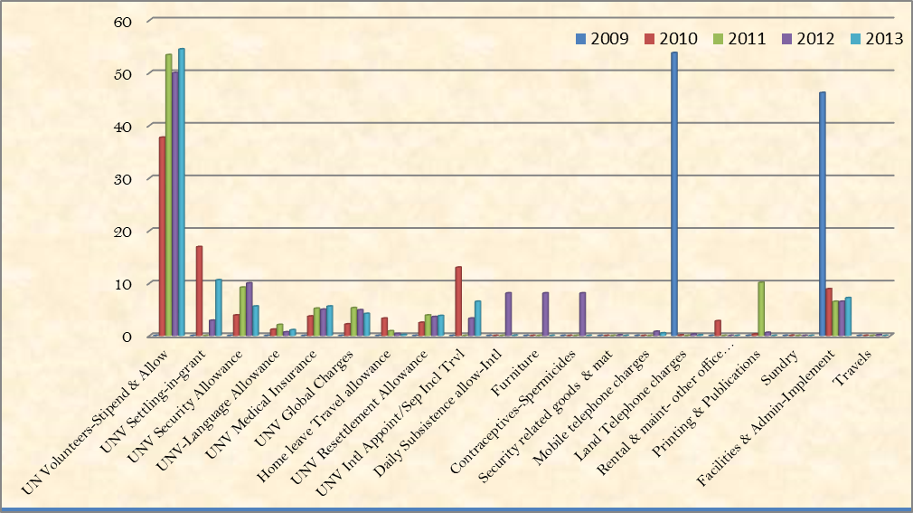

Analysis of the project spending patterns as reflected in the audited project reports indicated that the biggest percentage of the project funds has been spent on Volunteers stipend and allowances. In the base year (2009) project budget was spent only on land telephone charges as well as facilities and Administration. This is because these were the critical path activities of the project upon which the success of the subsequent project activities hinged. Analysis further shows a positive progression in the project spending pattern as the percentage of the project budget spent on majority of the project activities has steadily increased over time. The evaluation certainly established that the progressive increment in the project’s spending pattern has been in tandem with the volume of project activities and out puts thus it’s noteworthy that there has been value for money.

The evaluation further noted that project fund absorption rate has been reasonable a factor that explains the presence of balance rolled forward at the end of each project financial year. Despite a few gaps (lack of some supporting documents for certain payments) in the financial management system identified in the official audit reports, the project has been able to put a sound ATLAS financial management system which has ensured efficient utilization of project resources.

Furthermore, the official Audit reports(2012 and 2013) reviewed for this project also reflected expenditure on transportation, equipment, and security related goods and materials and publications(CDR Jan-March 2011) and furniture(CDR-Jan-Dec 2010) that were critical to the efficiency of the UNV Medical Doctors volunteer project.

Assessment of design and implementation of the Project
This section of the report discusses Projects’ concept and design, Implementation and Results in relation the evaluation findings.

Project concept and design
The project concept was excellent and is in line with targets aimed at contributing to the development agenda at both the national and global level. Key among these are the Millennium Development Goals (MDGs), contributing to the building of volunteerism spirit as well as skills development to enhance the capacity of nationals to meet capacity gaps in areas of health service delivery.

The design was clearly thought out given its multi-stakeholder comprising the Ministry of Health Social Welfare(MDGs),United Nations Volunteers (UNV), United Nations Development Programme(UNDP) and World Health Organisation(WHO),an approach that involved government and development partners. The advantage of this design was that it promoted national ownership as well as pulling the vital resources necessary for national development.

Implementation approach (Country ownership Stakeholder participation Cost-effectiveness)

The evaluation discerned that proved very key to implementation approach was the allocation of responsibility centres in respect to a stakeholder areas’ capacity to efficiently deliver on their inputs. Notable was that Ministry of Health and Social Welfare as a key decision maker was allocated a responsibility in identifying the required skill specific medical personnel as well as their deployment according to area of need. Further, away from the centre, districts authorities took charge of the Volunteering Doctors. This approach was key to promoting country ownership at the national and district levels.

Secondly, the issue of cost effectiveness was addressed by linking the project and other interventions within the health sector especially the capacity building programs. Notable among these was the skills development of resident health workers at hospital and health centre levels. However, the evaluation was unable to get statistics of how many and extent the health workers benefited in terms of skills and knowledge acquired.

Management arrangements
From the review of documents and interviews with key informants, the evaluation learnt that a tripartite arrangement involving UNDP/United Nations Volunteers (UNV), World Health Organisation (WHO) and the government of Lesotho through the Ministry of Health and Social Welfare (MoHSW) was put in place. Each stakeholder’s responsibilities were clearly assigned. The evaluation noted that the strengths that accrued from the tripartite arrangement was that the UN agencies brought on board skills that were crucial in selection and soliciting the crucial human and financial resources that ensured that project was accorded the critical support it deserved. However, the tripartite arrangement had its own weaknesses. The inability of one of the stakeholders to step in to undertake a responsibility not as before assigned delayed implementation of the program activities. For instance, the evaluation observed that weak or low capacity on the part of government to observe timeliness in sourcing the inputs and utilization and accountability of resources led to delays that affected the effectiveness of the project. For example the Ministry of Health and Social Welfare (MoHSW) delayed approval and recruitment of the doctors that delayed the commencement of the project for a year. Statistical trends show that 65% of the doctors recruited in 2013 a year to end the project an issue that might affected the effectiveness of the project.

Implementation
This subsection presents discussions on Monitoring systems, risk management, project management and partnership strategies.

Monitoring Systems
From the observations made during document review and key Informant interviews, the monitoring systems put in place during the project design seemed robust with a provision of periodic assessments and tools. Overall, the monitoring was efficient though it system suffered some weaknesses mainly attributed to poor records keeping within the Ministry of Health and Social Welfare (MoHSW). For example the evaluation was unable to get statistics from the Ministry of Health o the actual number of the junior medical personnel capacity was built and the actual waiting time for patients to access medical intervention as result of the intervention. As for other implementing partners, the UNV and UNDP a lot was done to carry out regular audits and monitoring the placement of the UNV medical doctors.

Risk management
The evaluation was able to learn from the interviews done with the Key Informants and documents reviewed that there was excellent risk management process during the project implementation. For example the UNV/UNDP and WHO carried out support through regular project brief meetings to cover the gap of limited or lack of experience by some District Medical Officers to manage Volunteer Medical Specialists.

Secondly, where it was found wanting in the process to avert the risk, the well capacitated partners gave a hand. For example to enhance the number of Medical Specialists in Government health facilities, WHO/UNV/UNDP support was enlisted by the government to facilitate initial screening and short listing of applications.

Rating of project implementation (employing six-point UNDP Rating Scale)
For Each Output and  Outcome to be rated for below | Rating to be scored for each | Key Justification for  rating
1. Relevance:  Improved service delivery in health facilities due to availability of qualified medical staff.  Stop gap for qualified medical personnel addressed | Satisfactory (S): The project had minor shortcomings in the achievement of its objectives, in terms of relevance, effectiveness or efficiency. | - Slow recruitment of Volunteer Medical doctors  - Some of the Medical doctors’ volunteers recruited/deployed into mainstream government service.
2. Effectiveness:  - 7 out of 10 regional hospitals benefitted  - Reported improved health service delivery where doctors were deployed  - In-service training for the local medical staff enhanced capacity building | Moderately Satisfactory (MS): The project had moderate shortcomings in the achievement of its objectives, in terms of relevance, effectiveness or efficiency. | All activities were carried out though not according to schedule.
3. Efficiency:  - Only 50 percent utilised  - Accountability not well done by government agency | Moderately Satisfactory (MS): The project had moderate shortcomings in the achievement of its objectives, in terms of relevance, effectiveness or efficiency. | Slow processes in recruitment of medical personnel  Most of the medical personnel deployed towards the end of the project.

Rating of Progress towards project objectives and outcomes (employing the six-point UNDP rating scale
Key issues | Rating | Key justification for rating
1. Financial resources:  Government financing not being consistently adequate | Moderately Likely (ML): There are moderate risk that affect this dimension of sustainability. | Reduced government incomes
2. Socio-political:  - UNDP/UNV and other partners willingness to support the initiative  - Sluggish government action executing the project activities  - Improved access to better services means citizens continue to embrace the project | Likely (L): There are no or negligible risks that affect this dimension of sustainability. | - Government commitment to supporting the project.
3. Institutional framework and  governance:  - Ministry of health and partners have already set up structures to support the project. For example absorption of former UNV medical volunteers into mainstream service  - Systems for accountability in place but government bureaucracy slow in embracing them. | Likely (L): There are no or negligible risks that affect this dimension of sustainability. | Partners willingness to improve on the management of the project
4. Environmental:  - Other support programs are in place to augment project activities.  - Gaps of Medical staff likely to reoccur if no extension is done | Moderately Likely (ML): There are moderate risks that affect this dimension of sustainability. | Service users willing ness to tap into the opportunity of improved service delivery
Overall Rating: |  | Reasonable progress has been made towards achieving objectives and outcomes

Lessons learned
This section of the report presents the lesson learned during the implementation of the project.
Positive lessons
- The recruitment and subsequent extension of services by some United Nations Volunteer Medical Doctors into Lesotho health service was novel innovation that enabled project continuity in the delivery on its outcomes after the project life time.
- Outreach programs initiated by the UNV Medical Doctors increased service access to rural communities that would otherwise have not been able to travel far distances to service delivery points.
Negative lessons
- A clear exit strategy was not put in place by the Ministry of Health and Social Welfare (MoHSW) prior to the conclusion of this project. Therefore, many of the health centres in which the UNV Medical Doctors were deployed were quite unaware of or were not officially informed by the Ministry of Health and Social Welfare (MoHSW) about the eminent departure of the UNV Medical Doctors after the conclusion of the project in 2014. Hence, the hospitals did not have any mechanism in place to fill the gaps of the UNV doctors when the project came to an end.
- Many of UNV Medical Doctors deployed at the hospitals in the districts did not receive the required orientation on the medical programmes of Lesotho and were therefore initially overwhelmed in terms due by cases of HIV/AIDS, different drug prescription regimen for some ailments quite different from countries (Philippine doctors) of origin and language barrier with the patients.

CONCLUSIONS AND RECOMMENDATIONS

This section presents the conclusions and recommendations of each of the projects. Part A-National Youth Corps and Part B- UNV Medical Doctors.

Part A: National Youth Corps

Conclusions
The evaluation concludes that the initiative was timely and indeed was very key to enabling Lesotho address national challenges of youth unemployment and HIV/AIDs in the long term. So far beneficiaries as well as host institutions have realized that there is always mutuality of benefits accruing for both the volunteer and the host institution. As for the government and its partners, the project was the appropriate vehicle through which development challenges can be easily tackled by mobilising the youth through such initiatives.

Promotion and response to volunteerism was taking positive direction given the number of youth enrolling and the willingness of private sectors to participate in the programme. The project rate of placement of the enrolled youth superseded the target there is still willingness on the part of UNDP and government to support the project given the progress so far made in making it a government programme and recruitment of the appropriate staff to run the project.

Recommendations
The recommendations hereunder are intended to guide addressing weaknesses experienced during the project phase of implementation as well as building on the existing strengths to ensure sustainability of the outcomes. Recommendations are presented along the following parameters:-Corrective actions for the design, implementation, monitoring and evaluation of the project
The evaluation strongly recommends for following:
- Since the project has changed from project to programme there was need to enhance its implementation through the decentralized structure up to the district level ensure there is wide coverage that exhibits national outlook. By adopting this approach, the rural youth who for one reason or the other cannot access the services in Maseru will benefit. As consequence, the project will in fact open more opportunities bringing on board many up-country based private sector and NGOs into the ambit of host institutions. The ultimate aim of mobilizing the youth to the volunteering call will be greatly enhanced and so will be their contribution to development of Lesotho.
- Ministry of Gender, Youth and Social Recreation that is responsible for the programme should come with laws and policies that ensure the Private sector, CSOs and Development partners make volunteers roster as a mandatory resource pool from which Human resources should be recruited so as to motivate the youth that got volunteer placements but did not immediately get job. This approach would encourage and even compel every youth to participate in the volunteerism thus more enrolled young graduates would come on board.
- The existing M&E system was very basic and only for monitoring the placements of volunteers. As for the future if the programme is to be strengthened, there will also be a need for an M&E system for the whole programme in order to check/monitor if other activities/objectives are achieved/been held so as to track efficiency and effectiveness of the programme.
- Furthermore, the current mandate on the national volunteers corps focuses on benefitting only university and tertiary graduates thus there is need for the government to widen the scope reorient the programme mandate to include all youth of working age through partnerships with development partners thus tackling the issue of unemployment at wider scale to reduce poverty in the country.

Actions to strengthen or reinforce benefits from the project
- There should be concerted efforts on the part of government and other stakeholders to mobilise youth who gain permanent jobs placement thereafter to contribute to the funding of NVC as part of the strategies to grow and strengthen it as self- financing entity.

Proposals for future directions underlying main objectives
- All the programmes to be implemented under the development assistance frameworks like UNDAF and CPAP and national development agenda should build on foundation laid down by the project and ensure volunteerism targeting the youth forms a core component. This opportunity should be exploited in the post MDG agenda.
- In future, clear responsibility centres have to be created to make sure responsibility centres for the entire NVC programme are enhanced especially within the Ministry so that management processes are easily carried out to meet the stated objectives of the programme.

Suggestions for strengthening government ownership, management of potential risks
- The Lesotho Government should fast track the policy and legal framework on to which the programme should be anchored so as to ensure that institutional framework with requisite skilled personnel and funding are put in place to have the project run smoothly to avert the risk of failure in future.

- Government should use its influence and clout to embed the project activities in bilateral and multilateral undertakings that are in line with the project so as to build capacity of the local personnel with skills and knowledge to run the program.
- UNDP country office should continue to support the project now turned into programme so as to ensure its much more robust as a fully self-sustaining government programme. This kind of support may be in form of financial and Human resources. One of the initiatives could be post assignment/graduate training courses, career guidance sessions where NVCs could interact with potential employers and corporate institutions. It should be noted that this kind of support could be delivered through well systems and structures with a clear budget line for long term NVC under strategic plan

- The fact that this NVC project mostly focused on fresh graduates the evaluator recommends that in future the government should widen the horizon in a more holistic strategic initiative to address unemployment across all segments of the youth by also reaching out to other lower levels such as tertiary institutions with a view of developing a skilled manpower. This also calls for the government to revisit the entire education curricula and syllabus in the education system
- There is need in future to clearly define the terms of references and roles and responsibilities for the placed volunteers in various institutions and organizations so that supervisors can be able to effectively utilize them in line with their qualifications and matching tasks
- The government should also strive to develop a fully-fledged multimedia communication and campaign strategy to diversify out in conjunction with National Youth Council and the District Youth Centres as well as bringing on board active participation of local civil society organizations as potential partners in scaling up Volunteerism for development in a more holistic manner

There is need for provision of basic facilitation and logistics for volunteers to take on their tasks effectively
- There is need for the UNV/ Government in future to clearly define communication channels through which volunteers should follow in order to avoid cases of misinformation to avoid situations that occurred in the past where some volunteers after receiving their allowances would duped their supervisors that they had been transferred to other ministries with an intent of not undertaking a full term of volunteering.

- There is need in future for the UNV office and governments to mount frequent checks and monitoring of host institutions in order to follow up on the working environment and performance of volunteers.

- Finally, there is need for the inclusion young people in the management of the programme by the MoGYSR as a way of ensuring its sustainability. Note that young managers are likely to appreciate the aspirations of fellow young people.

Part B: UNV Medical Doctors Volunteers

Conclusions

The conclusions drawn from the performance and implementation of the UNV medical doctors’ project are hereunder-

The evaluation concludes that the project made significant contribution to improving health service delivery and capacity building of medical staff given the increased health seeking at the district hospitals were the UNV doctors were deployed. Document reviews demonstrate the immense contribution the UNV doctors have made improved service delivery during the project implementation through specialised services (patients attended daily increased from 400 to 1000). Overall, the medical doctor treated an estimated 22,000 patients benefitted from rounds in general wards and outpatient services hence boosting health service delivery in terms of reduction in patient waiting time and improved patient doctor ratio. In terms in helping to meet some of the MGDs is exemplified in training Junior medical staff in anaesthesia, HIV/AIDs treatment guidelines developed and voluntary male circumcision programs were aimed to reduction of HIV/AIDS,TB and maternal death related as prescribed in MDGs targets. This development supports the conclusion that indeed there was improved service delivery albeit delays in recruitment and deployment of the doctors in district hospitals.

Whereas the activities and capacities of the project did expand the provisions of specialised health services, there no clear transition put in place for continued delivery of the services once UNV medical project wound up. Evidence from the interviews and document, show that there was worry that the outcomes of the project may at one point evaporate if no measures for continuity are clearly put in place such as extension of the project pending stock taking measures to properly align the project to other interventions particularly the WHO human resource building programme.

Recommendations
The recommendations hereunder are intended to guide streamlining the current implementation, bridge the weaknesses as well as building on the existing strengths of the projects as it came to end of its life to ensure sustainability of the outcomes. Here below are the recommendations:

Corrective actions for the design, implementation, monitoring and evaluation of the project
- In future the UNV doctors should be deployed in the districts as opposed to being placed at the MoHSW headquarters since there is more need in the districts due to lack of skilled medical staff.

- There should be deliberate efforts by the Ministry of Health and Social Welfare to use the project as a key capacity building initiative of local junior medical staff by drawing up plans and targets in respect to skills and knowledge needed so as to adequately address the human resource gaps in the health sector.

- The monitoring system should be revisited by the MoHSW to make it much more responsive to capturing the detailed data right from the service delivery point to the ministry level so that accurate statistics are captured to inform future planning in the health sector to address the human resource gaps.

Actions to strengthen or reinforce benefits from the project
- Specifically for the UNV Office, there is need for recruitment of a Technical Program Assistant to support the current UNV Program Manager since the substantive UNV Program Assistant was handling Administrative/financial management support than technical UNV work.

- To ensure continuity of the benefits, there is need for more UNV doctors and this time recruitment should be scaled up so that in the successor program, the highly needed medical personnel specialised in clinical disciplines such as Gynaecology, Obstetrics, Orthopaedic surgery, Anaesthetic, Paediatrics are recruited as opposed to general practitioners and public health specialists.

Proposals for future directions underlining main objectives
- UNV doctors recruitment should target doctors from the region as a priority and if they cannot be found, then doctors recruited outside the region should be fully inducted and taken through courses in the basic local language training to enable them have a better start in the hospitals where they are placed

- There is need to decentralize Doctors not only to government hospitals but also placing some under the Public Private Partnership arrangement in private hospitals that serve a bigger catchment area as well as fully equipping and staffing them to the level of a provincial referral hospital.

- Apart from Specialist UNV Medical Doctors, the government should also provide psycho social counselling services to the patients especially with this HIV/AIDS epidemic where UNV medical doctors were challenged. This would enable doctors’ focus more on their core functions of rendering specialised services as and when required.

Suggestions for strengthening government ownership, management of potential risks

- there is need for the government to provide adequate equipment and facilities(basics for Anaesthesia and oxygen) in order for the specialists to effectively deliver their services at the place of work.

- In future MoHSW/UNV should develop an orientation program for the new volunteers recruited both at national and district levels. The doctors’ orientation should introduce them to full information on health service delivery system within the country as well as policy and regulatory framework, HIV/AIDS, drug regimes, social and cultural norms and values of the country.

- Lesotho being a hard hit country by HIV/AIDS, there should be concerted government effort together with development partners in continuing special focus on practical strategic initiatives in addressing the HIV/AIDS scourge since it has a direct correlation with the level of poverty and unemployment especially with the youth.

6.0 Annexes: (Double click to open)

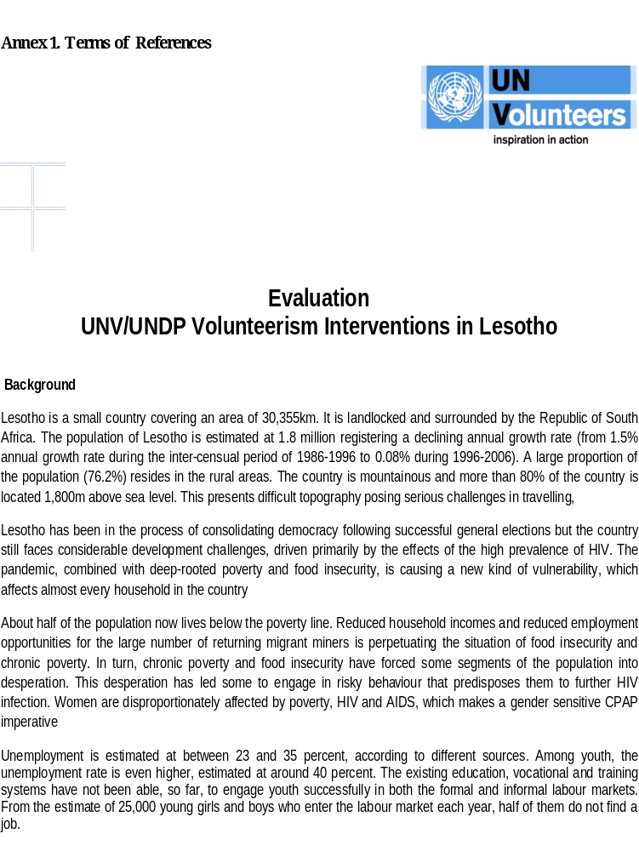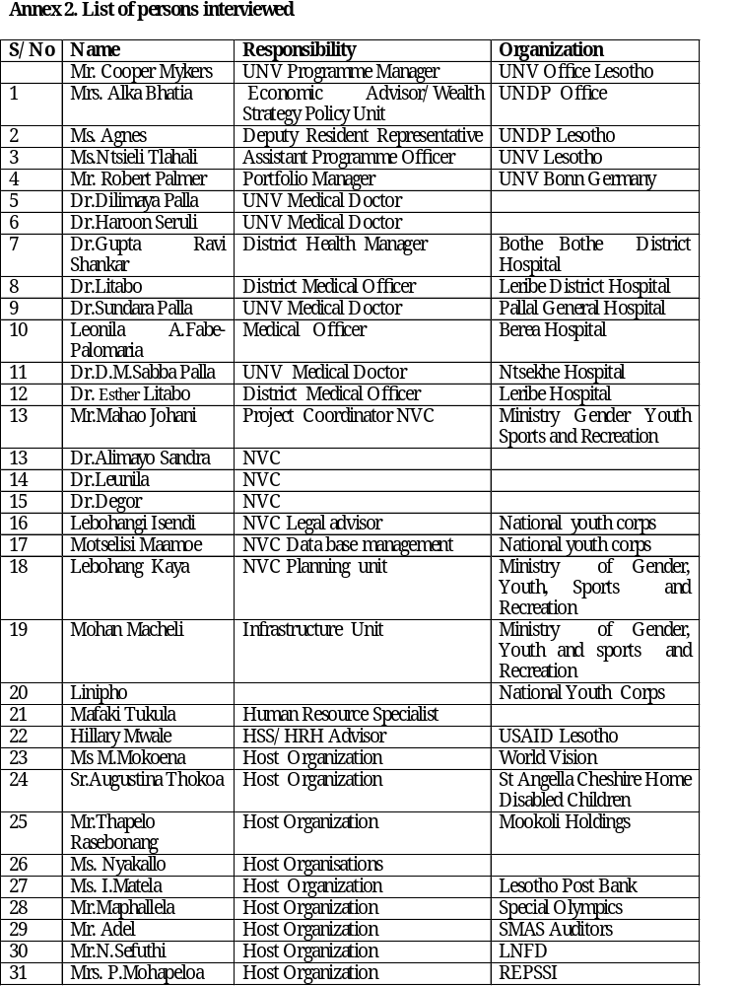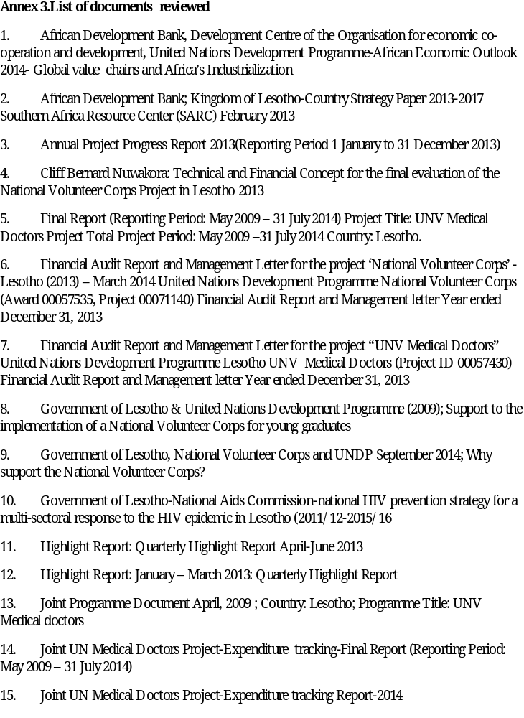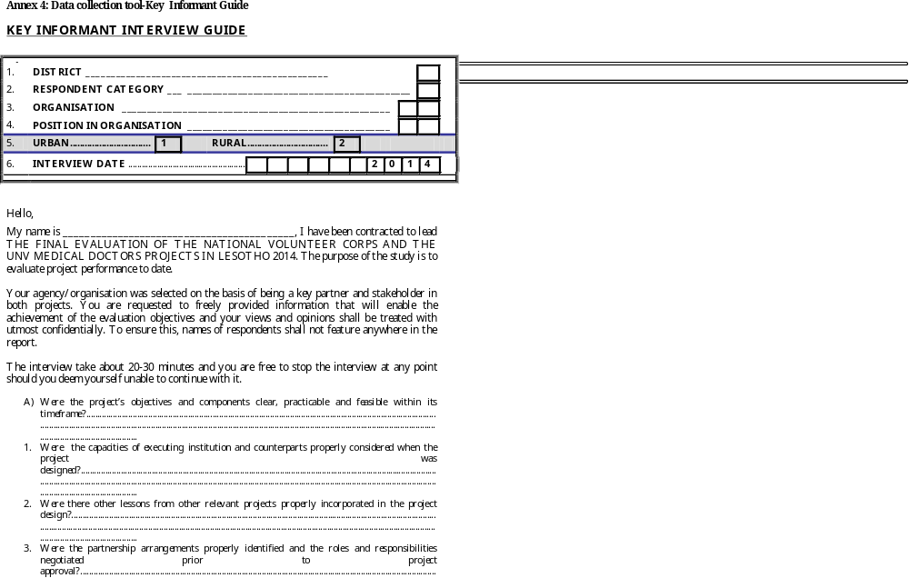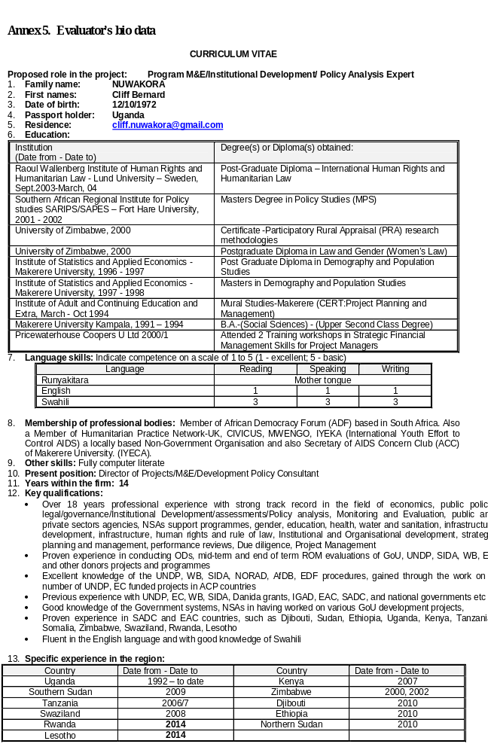

Interview with the VSO policy advisor
Interview with the VSO policy advisor
Interview with VSO policy advisor
Interview with VSO policy advisor
Final report UNV medical doctors project Lesotho 2014
Annual Highlight Report-January-December 2013

